Monday through Thursday collection only.

\*\*unless arrangements for incubation and centrifugation are made with your technical consultant\*\*

1. Obtain 4 Tube QuantiFERON-TB Gold Plus Kit
2. 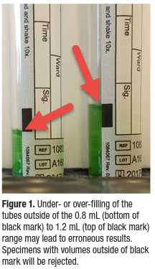Collect 1 mL of blood into each of the 4 tubes (Figure 1-shows acceptable range).
   1. Tubes fill slowly.
      1. If desired, use of a syringe may ensure correct blood volume. Collect between 4- 5 mL of blood into a 5- or 6-mL syringe and transfer 1mL of blood into each of the 4 tubes.
   2. When the tube is upright, blood must meet the small black mark on the label.
   3. If butterfly needle is used, first collect other required tubes or use a “purge” tube to remove the air and then proceed with collecting the QTB tubes.
   4. These tubes are manufactured to draw 1 mL of blood and perform optimally within the range of 0.8 to 1.2 mL.
   5. If the level of blood is outside of the black indicator line, another blood specimen should be collected (see figure 1). Samples will be rejected if outside the fill range
3. Immediately shake the tubes firmly 10 times.
   1. Entire inner surface of tubes must be coated with blood.
   2. Overly energetic shaking may cause gel disruption and could lead to aberrant results.
   3. Thorough mixing is required to ensure complete integration of the tube’s contents into the blood.
4. Label tubes appropriately. The label should be placed so back window and black marks are visible on all 4 collection tubes.
5. Maintain tubes at room temperature (17°C–27°C) until incubation. Do not refrigerate or freeze.
6. Incubation to be performed at SLH must be started within 16 hours of collection.